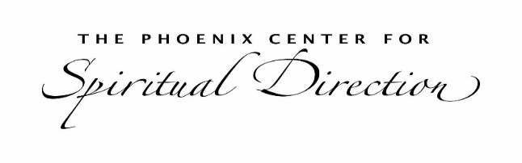

APPRENTICE TRAINING PROGRAM ENGAGEMENT AGREEMENT

We greatly appreciate you being a directee for one of our Apprentices in training to become a spiritual director. Please sign and return to your trainer as soon as possible. Emailing and using a digital signature is acceptable.
What Spiritual Direction is About
Spiritual direction is a confidential conversation between a director and directee with only one goal: to help the directee explore their relationship with the Divine and grow more deeply in that relationship. Although all life situations are appropriate to discuss in spiritual direction, the focus of the ongoing conversation will be to expand spiritual awareness. Spiritual direction is not therapy, counseling, or coaching. Your director will not diagnose or give advice, and any decisions or actions you make as a result of spiritual direction are solely your responsibility.
Confidentiality
Confidentiality is important in spiritual direction. Your time with the director is sacred and your director will only talk with their trainer/supervisor about any session—and only so that the director can learn to better listen and explore with you. As a directee, though, you are free to share whatever you choose about the direction conversations with anyone.
Supervision Requirements for your Director
For an Apprentice in this program to receive their Certificate of Completion, they are required to do three (3) Zoom recordings of spiritual direction sessions they have done.
These sessions are for educational and supervision purposes, designed only to focus on the gifts and skills of the spiritual director. If you permit this recording, the Apprentice you meet will:
- Let you know at the beginning of the session that they are recording the session.
- Use this video only for the purposes of supervision—to learn how to be a better spiritual director.
- Delete the video after the session where it is discussed in the program.
- Keep confidential the content in the video and what is discussed for supervision purposes.
We would appreciate receiving your written agreement to allow the Apprentice to record selected sessions. However, it is not mandatory.
Please look over this engagement and video agreement and sign accordingly.

Program Engagement Agreement

I, ____________________________________________(name) on ____________________(date) am agreeing to be in spiritual direction with ___________________________(trainer) during their time in the Apprentice Training Program.

Video Agreement (optional)
I, ______________________________________ am aware that an upcoming spiritual direction session may be recorded for educational and supervisory purposes and will only be viewed in the context of this training program for supervision purposes. By signing my name, I am agreeing to this video recording. It is my understanding that the video will be deleted by my apprentice spiritual director.
Thank you! We are so grateful for your participation. Doing so will ensure that your spiritual director is able to learn from their experience with you—and will become a better spiritual director for it. In this way, you are benefiting not only the director but everyone they work with in the future!
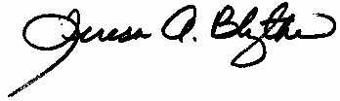
Teresa A. Blythe, Director of the Phoenix Center for Spiritual Direction’s Apprentice Training Program.
Questions? Email teresa@teresablythe.net

